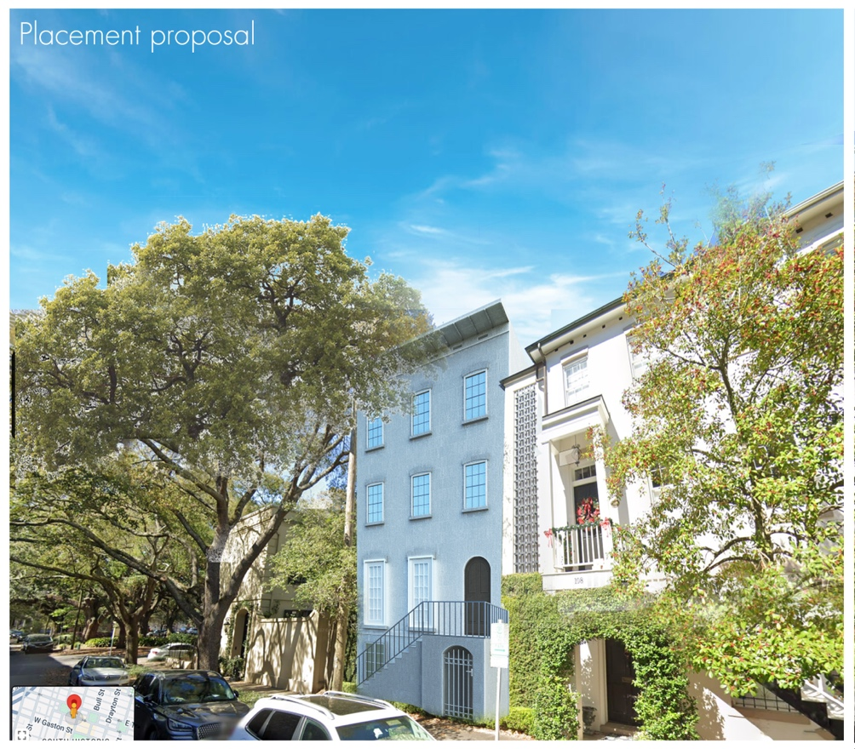

Architectural Concept

108 W Gordon St

Opportunities for redevelopment:

• Opportunity 1: Rehabilitation the existing house and carriage house as-is. A COA will be required for any exterior alterations.

• Option 2: Add on to the main house in the courtyard area, connecting the existing garage. Based on the maximum lot coverage, this could be an addition of 944 square feet maximum.

• Option 3: Subdivide the parcel on a north south axis and construct a new principal dwelling facing West Gordon Street. The new building could be four stories, but I'd recommend three from an approval perspective. Parking would have to be provided for the historic building.